Process: This job aid describes how to use WebNow

WebNow
Website | https://cm.itap.purdue.edu/webnow/
WebNow Requirements | Currently WebNow requires the following to be installed on your computer.  - Internet Explorer  - Java version 1.8.0_xxx or below  - Access to the VPN  Please Note – All VPN networks should work to access WebNow. If you are unable to launch WebNow please try the VPN: webvpn2.purdue.edu
Viewer Role Requirement | The below security roles are necessary to view documents within WebNow. Requests for these roles should be done through Success Factors.  BI150_000_FI_DATA_LEVEL_1 – Will give access to the Finance Viewer along with PARS and CD01 Viewer  GM800_000_DISPLAY – Will give access to the Post-Award Viewer
Troubleshooting | If you do not see the below image after you go to https://cm.itap.purdue.edu/webnow/  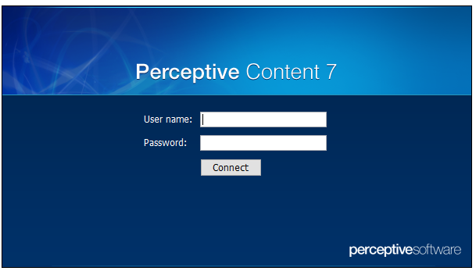  Confirm you are in Internet Explorer and Java 1.8.0 or greater is installed
Java Confirmation | In your bottom search bar search for “Configure Java” and launch the Configure Java application.  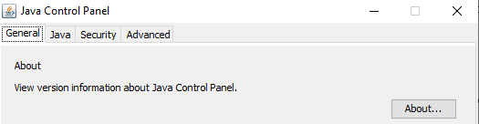  Click the “About” button and it will tell you what version of Java is installed  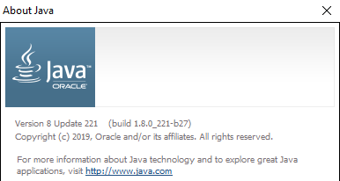
IE Toolbar in Chrome | For users able to navigate Google Extensions you can install an IE Toolbar that will allow you to launch WebNow in Google Chrome.  While in Google Chrome at the top right of your screen you should see the following button.  Click it and then select “Settings”  In the bottom left there is an “Extensions” button and click it.  In the top left you will see the following . Click the 3 lines and at the very bottom you should see an option to “Open Chrome Web Store”  Open this and search IE Tab  Click on the following option  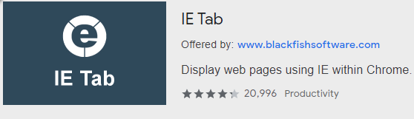  And add it to Chrome. You will get an installation box at the bottom of your screen to install it to your computer.  After it is installed close out of Chrome completely and go to https://cm.itap.purdue.edu/webnow/. By your URL bar to the right of your screen you should see the following button now.  When you click it you should see and “IE Tab” option. Select it and the following should show up to your screen.  After a few seconds you should now see the login box to WebNow.  PLEASE NOTE – THE IE TOOLBAR IS NOT SUPPORTED BY ITAP AND SUPPORT WILL MOST LIKELY NOT BE GIVEN.

